Droughts and Despair: An Innovative Tool for Policy-Makers to Assess Climate Change's Economic Impact on “Diseases of Despair” in Farming Communities

C. Arsene

Department of Mathematics

Faculty of Science and Engineering

University of Manchester

Email: carsene@tuta.io

This project focuses on developing an innovative tool and resources for policymakers to understand better policy impacts on climate change, agricultural economies and health nexus specifically “Diseases of Despair” in farming communities. The developed tool integrates climate data, farm stats and health indicators offering a more detailed picture of their interplay. The tool allows policymakers to simulate policy scenarios like introducing drought-resistant crops to boost productivity and reduce despair-driven health issue or creating social safety nets to protect communities during climate-driven agricultural downturns. Our goal is to offer an on-line platform for policy decisions, helping to alleviate climate change’s direct and indirect health effects on vulnerable groups. Using climate, agricultural and health data from a South Asia country (i.e. India), our prototype model and web application showcases our approach’s feasibility.

The technical documentation is focusing on three aspects:

1) Description of the input dataset(s).

2) The standalone programming file ‘newcalculatedirectandindirecteffect.R’ which calculates the direct and indirect effects of climate change on health and economy by using a multiple linear model.

3) The more complex software tool (app.R) which is mentioned above and which is available on-line <https://cornar.shinyapps.io/thirdapp/> and it is using R language programming and Shiny (R) app programming.

**1. Description of the input dataset**

The main dataset (‘Dataset.xlsx’) is obtained from public on-line resources for 28 states of India covering period 2010 to 2021 and containing the following spreadsheets :

- health outcome of farmer population which is death due to a mental health crunch (spreadsheet Outcome).

-yearly maximum temperature (spreadsheet Maximum Temperature),

-yearly maximum precipitation (spreadsheet Maximum Precipitation),

-yearly minimum Standardised Precipitation Evapotranspiration Index (SPEI) (spreadsheet SPEI),

-Gross Domestic Product (GDP) obtained from agriculture per year (spreadsheet GDP Agriculture),

-farming gross irrigation area per year (spreadsheet Irrigation area),

-credits given to farmers per year (spreadsheet Credit to farmers),

- number of farmers for year 2011 (spreadsheet Farmer).

The 28 Indian states for which the data is available are Haryana, Jharkhand, Karnataka, Kerala, Madhya Pradesh, Maharashtra, Puducherry, Tamilnadu, Chhattishgarh, Telengana, Andhra Pradesh, Goa, Himachal Pradesh, Punjab, Rajasthan, Uttarakhand, Uttar Pradesh, Sikkim, Assam, Arunachal Pradesh, Nagaland, Manipur, Mizoram, Tripura, Meghalaya, Bihar, Jammu and Kashmir, Delhi.

The public on-line resources used to generate the dataset were:

1) Maximum temperatures, maximum precipitation in India:

<https://www.worldclim.org/data/worldclim21.html>

2) SPEI index for India:

<https://www.nature.com/articles/s41597-023-02856-y>

(The SPEI index was taken from publication Chupal, D.S., Kushwaha, A.P., Aadhar, S., Mishra, V., “Drought Atlas of India, 1901-2020”, Scientific Data, 11(7), 2024, and it was calculated the min, max and mean values per year and per each Indian state.)

3) The Gross Domestic Product from agriculture , the irrigation area and the credits to farmers:    <https://rbi.org.in/>

4) The farmer health outcome: [www.data.gov.in](http://www.data.gov.in/) .

The dataset has a DOI: 10.5281/zenodo.15001296 .

**2. Programming .R file newcalculatedirectandindirecteffect.R**

This programming .R file (newcalculatedirectandindirecteffect.R) calculates the direct and indirect effects of climate change on health and economy by using a multiple linear model. This software .R programming file has a DOI: 10.5281/zenodo.15013718.

The climate change can affect the health **directly** (i.e. direct effects) such as through exposure to droughts, dry climate, flooding or spread of infectious diseases, but can also **indirectly** (i.e. indirect effects) impact health via economic effects, a relationship complicated by unseen factors that might skew the understanding of the policymakers regardless of whether there are used sophisticated statistical models or machine learning techniques (i.e. Figure 1).

In this example, a country from South Asia (i.e. India) is used as a case study and the health outcome, which is death due to a mental health crunch, of the farmer population from this country (India) is available per year between 2010 and 2021.

The India country case study covers 28 country states for which the direct and the indirect effects are calculated. The status of economy is given by the Gross Domestic Product (GDP) from agriculture for the period of time 2010 to 2021. The ‘Dataset.xlsx’ input file is required by the .R file (newcalculatedirectandindirecteffect.R) in order to obtain the results.

GDP from Agriculture

b

c

Indirect_effect = b * c

Direct_effect = a

Maximum Temperature

Health Outcome

Figure. 1. Directed Acyclic Graph (DAG) diagram containing confounder (e.g. maximum temperature, maximum precipitation, SPEI index), mediator (GDP from agriculture), outcome (health outcome): direct and indirect effects of maximum temperature on the health outcome are shown.

The numerical results show some clear positive direct and indirect effects of the climate change on the health outcome when the GDP from agriculture is used as a mediator variable between climate change and health output, which may underline the effects that climate change can have on the agriculture.

**3) Software tool for policymakers to understand better the impacts of climate change on agricultural economies and health outcome specifically “Diseases of Despair” in farming communities.**

A more elaborated software tool (app.R) providing also a graphical user interface and designed for policymakers to evaluate the impacts of climate change on agricultural economy and health for the South Asia country case study (i.e. India) it is available on-line <https://cornar.shinyapps.io/thirdapp/> .

The software tool (app.R) is implemented in R language programming and Shiny (R) app programming, it has a DOI: [10.5281/zenodo.15046373](https://doi.org/10.5281/zenodo.15046373) and it can be run also locally requiring the inputs files described below.

The mathematical models are based on the multiple linear model.

It is possible to choose between two models by clicking on either ‘Model 1’ or ‘Model 2’.

Model 1 is shown below where the Maximum Temperature is the confounder , GDP from agriculture is the mediator and the health outcome is death due to a mental health crunch.

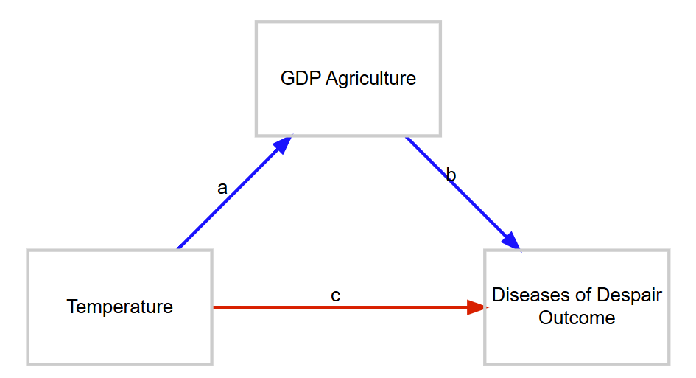

Figure 2. Model 1

For model 1, the multiple linear model and the calculation of the direct and the indirect effects consist of the following equations :

Outcome = Temperature x c + GDP_Agriculture x b (1)

GDP_Agriculture = Temperature x a (2)

Direct Effect = c (3)

Indirect Effect = a x b (4)

Model 2 is shown below where the ‘Maximum Temperature’ is the confounder, ‘GDP from agriculture’ is the mediator, the health outcome is death due to a mental health crunch, but now in addition from model 1 there are added also the ‘Irrigation area’ as moderator variable and the ‘Credit to farmers’ as a risk variable.

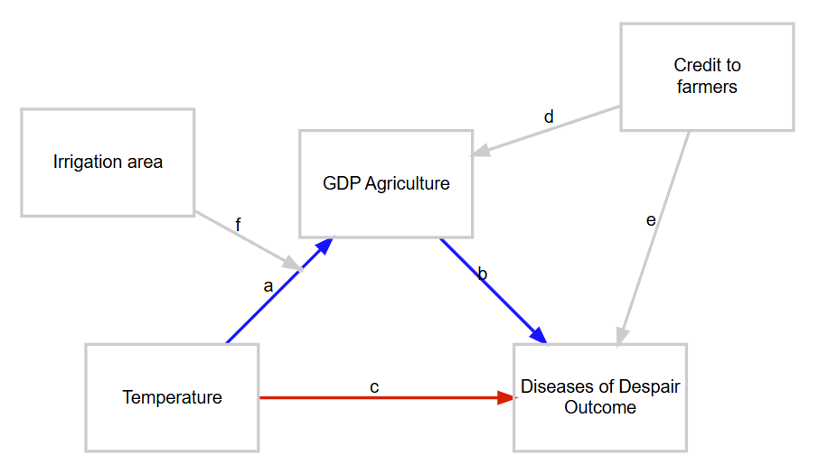

Figure 3. Model 2.

For model 2, the multiple linear model and the calculation of the direct and the indirect effects consist of the following equations :

Outcome = Temperature x c + GDP_Agriculture x b + Credit_to_farmer x e (5)

   GDP_Agriculture = Temperature x a + Credit_to_farmer x d +

(Temperature x a) : (Irrigation_area x f) (6)

Direct Effect = c (7)

Indirect Effect = a x b (8)

where : is interaction effect between two variables (i.e. multiplication of two variables).

A.Steps to follow in order to run the software tool:

1. The user has to upload the input file ‘Dataset.xlsx’ in the ‘Data Input file’ field.

2. The user has to unzip on the personal desktop the file ‘Country map.7z’ available in

github.

3. The user has to upload all the unzipped files in the ‘Country map shape file’ field.

4. The user has to select either ‘Model 1’ or ‘Model 2’.

4. The user has to click the button “Calculate Direct and Indirect Effects”.

B. To visualize the results:

1. Click on the following tabs in order to visualize a summary of the content of the

‘Dataset.xlsx’ file, while several images are shown also below as examples:

Climate:

Maximum temperature distribution over India for period 2010 to 2021.

Maximum precipitation distribution over India for period 2010 to 2021 (example

shown below).

SPEI index (minimum values) distribution over India for period 2010 to 2021.

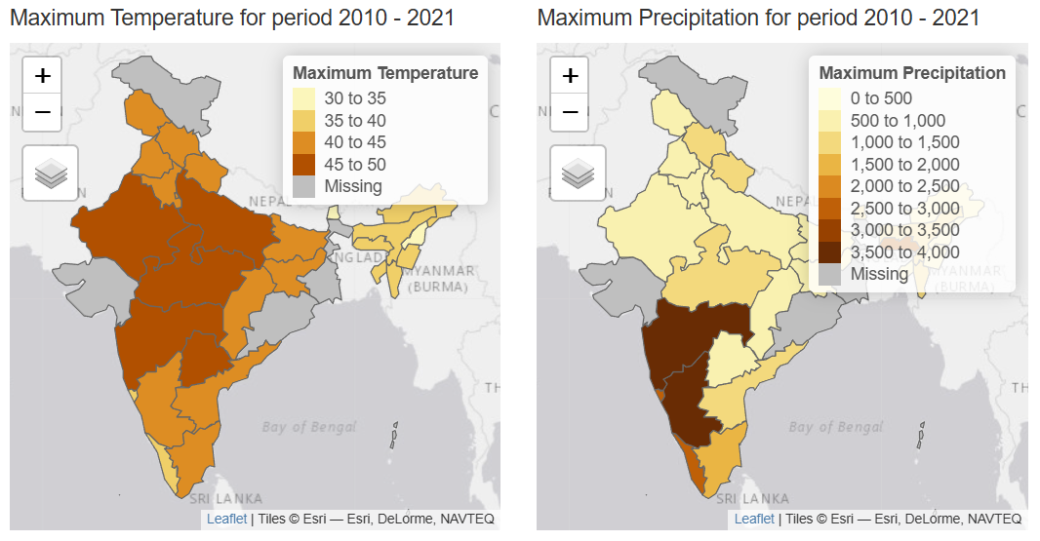

Economy:

GDP from agriculture (minimum values) distribution over India for period

2010 to 2021.

GDP from agriculture (maximum values) distribution over India for period

2010 to 2021 (example shown below).

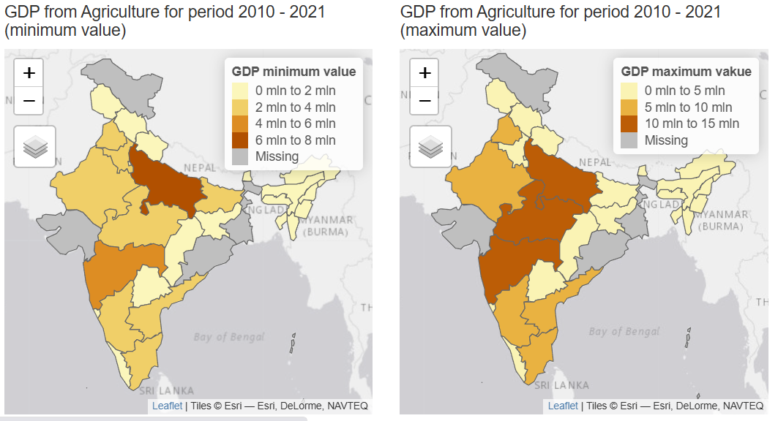

Workers background:

Credit to farmers (maximum values) distribution over India for period 2010 to

2021.

Irrigation areas (maximum values) distribution over India for period 2010 to

2021.

2. Click on Health Numerical Results to visualise the numerical results consisting of

the direct and the indirect effects for each Indian state (example shown below).

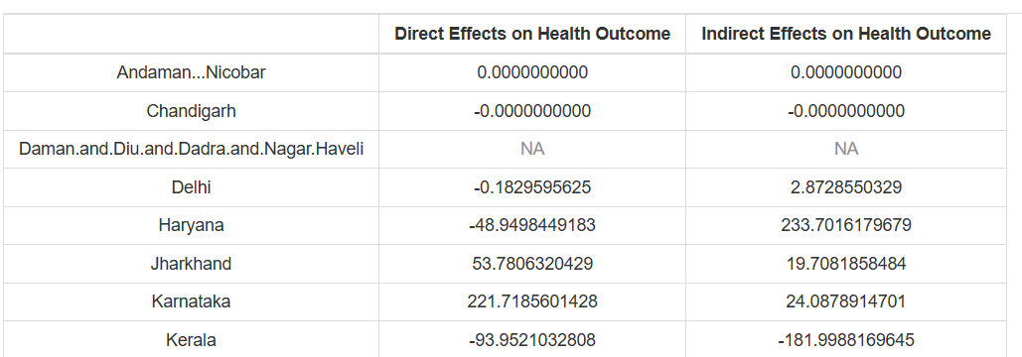

3. Click on the Health Maps to visualise the actual maps with the direct and indirect

effects distribution over India for each state (example shown below).

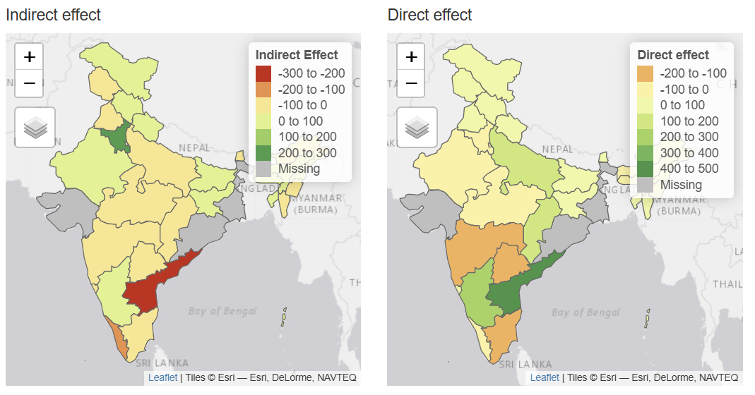

**Policy scenarios for policymakers**

The content of the various spreadsheets such as ‘Maximum Temperature’, ‘GDP from agriculture’, ‘Credit to farmers’, ‘Irrigation areas’ from the ‘Dataset.xlsx’ file can be varied/changed so that to allow the policymakers to simulate policy scenarios like introducing drought-resistant crops to boost productivity and reduce despair-driven health issue or creating social safety nets to protect communities during climate-driven agricultural downturns: for example, introducing drought-resistant crops to boost productivity can be simulated by increasing or maintaining constant the GDP from agriculture, while the maximum temperature would stay the same or would be slightly increased in the states with high GDP from agriculture. This simulated data would produce a new input dataset file (e.g. ‘Dataset1.xlsx’) which would need to be uploaded again on-line by the Shiny R app and then the steps described in “A.Steps to follow in order to run the software tool” would have to be repeated.

This technical document has also a DOI 10.5281/zenodo.15046374 .

**Acknowledgment**

This research project was financed by Wellcome Trust UK funding body grant number 228264/Z/23/Z.